Learning Guide:

United States of America Topographic Map

Overview:

The United States of America has a very diverse landscape—from having tall mountains to flat plains. A topographic map shows different mountain ranges and elevations. This model is a 3D version of a topographic map and allows one to feel the landscapes across the USA. The model is 11.5 inches (29 cm) wide and the United States is 2,800 miles (4506 km) wide. Each inch on the model represents about 243 miles of the United States, meaning that the model is 1/15,426,782 of the size of the United States.

Model designed by OpenSourceClassroom from https://www.thingiverse.com/thing:634007
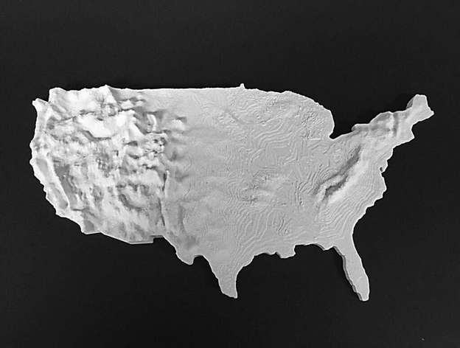
The photo above depicts the 3D model of the United States of America topographic map.

Walkthrough:

1. Start by placing your finger on the left edge of the model. Then, drag your finger down the left side of the model, and while doing so, you will feel bumps, ridges and valleys. You are feeling the Coastal Ranges which are a series of mountain ranges that run parallel to the Pacific Coast for thousands of miles. The Coastal Ranges span across Washington, Oregon and California. To the right of the Coastal Ranges, you will feel a dip that is long, but not very wide. This is the Central Valley which is located in between the Coastal Ranges and Sierra Nevada (another mountain range) within California.

2. After feeling the Coastal Mountains, move your finger slightly east. You will feel bumps and ridges, but these bumps won’t be as raised as the Coastal Mountains. You are feeling the Great Basin which is a series of mountains that cover the majority of Nevada, and are partly in Idaho, Utah, Oregon and California.
3. Move your finger slightly east from the Great Basin till you feel a line of mountains which start from the North side of the model and run Southeast. You are feeling the Rocky Mountains, which is a mountain range that spans from Canada into Montana to New Mexico. The Rocky Mountains are the longest mountain range in North America and have a span of about 3,000 miles. You should notice that this mountain range is composed of taller mountains than the rest of the mountains on the model.

4. Move your finger East till you no longer feel bumps or valleys and the model feels flat. The flat area that you are feeling is the Great Plains. Prairie, steppe and grasslands constitute the Great Plains and span across 10 states--North Dakota, South Dakota, Montana, Wyoming, Kansas, Nebraska, Oklahoma, Colorado, New Mexico and Texas. The flat land, fertile soil and hot summers make the area ideal for large-scale farming, especially for growing wheat. When feeling this area, notice how the Great Plains make up a large portion of the United States.

5. After feeling the Great Plains, move your finger East until you feel a series of raised bumps. These bumps represent mountains part of the Appalachian Mountain Range which is almost 2,000 miles long. The Appalachian Mountains are located mostly in parts of Tennessee, Kentucky, Maryland, Virginia, North Carolina and West Virginia.

Citations

“Appalachian Mountains.” New World Encyclopedia, New World Encyclopedia, 2020, www.newworldencyclopedia.org/entry/Appalachian_Mountains.
“Great Basin National Park (U.S. National Park Service).” National Parks Service, U.S. Department of the Interior, 4 Apr. 2020, www.nps.gov/grba/index.htm.
“Rocky Mountain National Park (U.S. National Park Service).” National Parks Service, U.S. Department of the Interior, 29 May 2020, www.nps.gov/romo/index.htm.
“Topography of the United States.” Encyclopædia Britannica, Encyclopædia Britannica, Inc., 2020, kids.britannica.com/students/assembly/view/166203.

